1. In this applet, we assume the radius, the mass and the moment of inertia of the wheel are all 1 unit.
2. The objects marked with a red arrow in the following diagram are capable to be dragged before the "Start" button is pressed.
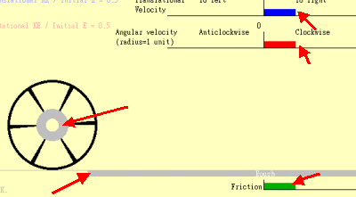
3. The two color strips shown at the bottom help us observe the slippage between the wheel and the road surface.
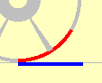

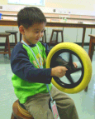
Kids like playing physics !

