Drag the pendulum bob to one side and release.
The bob may (i) oscillate or (ii) undergo a complete or incomplete circular motion, depending on the level of release and whether the pendulum is interrupted by the pin.
Assumptions:
(1) All frictional forces are negligible.
(2) The string is inextensible.
(3) The radial velocity of the bob will disppaear instantly when the string becomes straight after a free fall.

No interruption: The bob oscillates to and fro. A graph showing its displacememt against time is traced and compared with the corresponding SHM graph shown on the background.
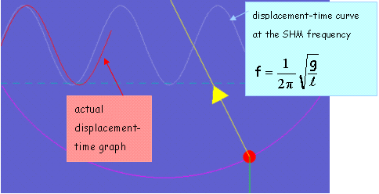
The oscillation is simple harmonic only when the amplitude is small.

With pin-interruption: The subsequenct motion relies on which region(I, II or II) the bob is released.
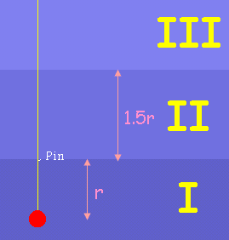

Region at where the bob is released
I | 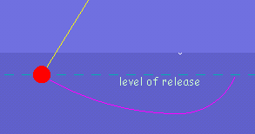  No work is done on the bob by the tension, so the sum of kinetic energy and potential energy is always a constant.
II | 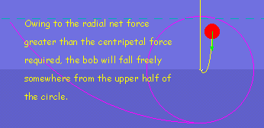
This is a jumping pendulum.
II | 