1.
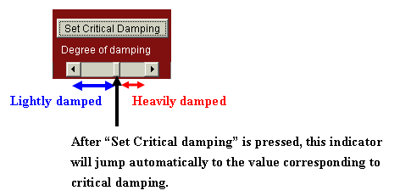
2.
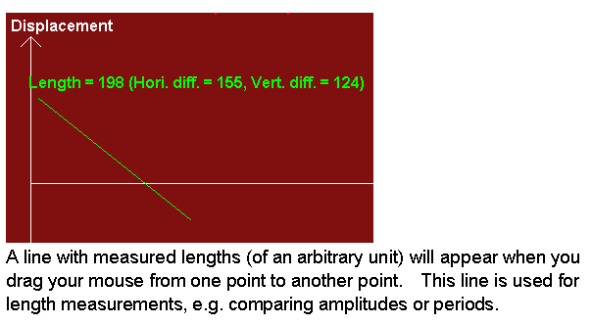
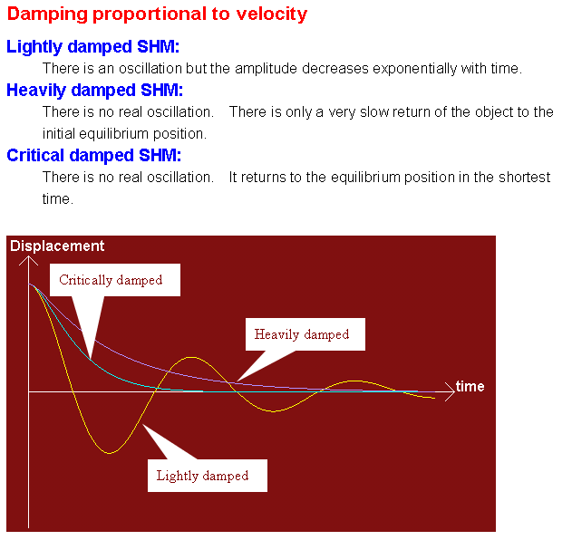
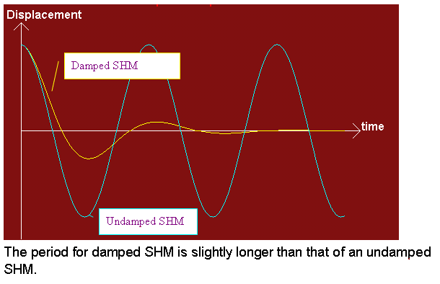
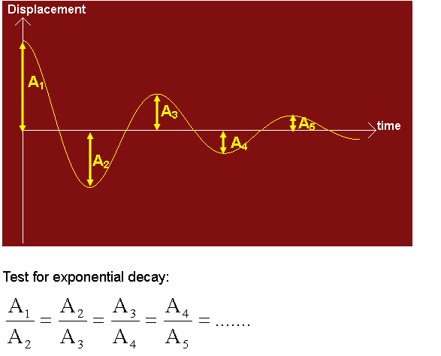
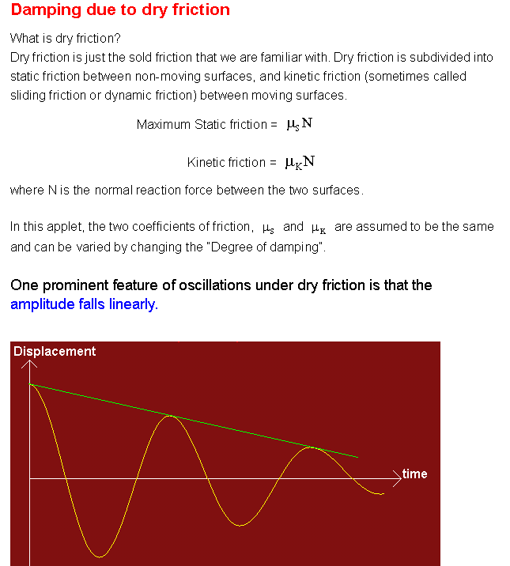
amping due to dry friction is seldom taught in school. If you want to know more about it, please read the following two papers:
M.I. Molina, "Exponential Versus Linear Amplitude Decay in Damped Oscillators," Phys. Teach. 42, 485-487 (November 2004).
Martin Kamela, "An Oscillating System with Sliding Friction," Phys. Teach. 45, 110-113 (February 2007).

