Tip-to-tail method of addition of vectors:
1. Translate the vectors and join them together in a chain such that the tip of one is attached to the tail of the preceding one (tip-to-tail method).
2. The order of vectors in forming a "tip-to-tail" chain does not matter.
3. Draw a new arrow from the tail of the last arrow to the tip of the first one, this is the resultant vector.
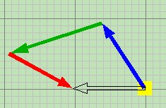 | 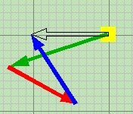 | 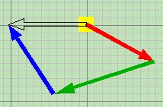
Although the vectors are joined "tip-to-tail" in different orders, same resultant (hollow arrow) is obtained.

In this applet, up to 4 forces (vectors) can be created in a random manner. The tip of each force can be dragged to move, hence its magnitude or/and direction can be changed.
When the button " Vector sum" is pressed, the forces will translate one by one automatically to form a "tip-to-tail" chain. The order of vectors in the joining is random.
Unless the forces are balanced, a black hollow arrow appears and blinks a few times after the completion of a "tip-to-tail" chain. This hollow arrow is the resultant force, which represents the overall physical effect of the original forces.
User is advised to repeat the "Vector sum" (press "Restore" each time to restitute) several times to see how the same resulatnt be obtained despite the order of arrows in forming the "tip-to-tail" chain in each time is different.
The "F" in Newton's second law of motion (F = ma) is the resulatnt force acting on an object of mass m. The acceleration thus produced is in the same direction of the resultant force.
When the button "Motion' is pressed, the yellow object will go and accelerate under the influence of the resultant force.

