If all the displacement vectors of the oscillating particles in a transverse wave are in one fixed plane, then the wave is plane-polarized (linearly polarized).
Wave is circularly polarized when the displacment vector rotates as seen by an observer toward whom the wave is moving.
Wave is unpolarized (e.g. natural light) if the polariztion at one point changes rapidly (for every 1 ns in natural light) and in a completely unpredictable fashion.
Polarizer is a device which transmits only the component of polariztion which is parallel to its transmission axis. By using a polarizer, the plane of a plane-polarized wave can be changed; a circularly polarized or unpolarized light can be changed to plane-polarized.

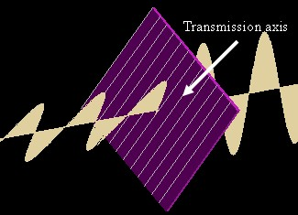
No wave can pass through two polarizers whose transmission axes are crossed perpendicularly. However, when a third polarizer is inserted between them with an angle not parallel to either one, some wave can finally pass through.
Malus' law: The intensity (proportional to the square of amplitude) of the wave passing through a polarizer (I) is the intensity of the incident plane-polarized wave (Io) times the square of the cosine of the angle between the transmission axis of the polarizer and the incident polariztion (θ), i.e. .
When a circularly or unpolarized wave is incident on a polarizer of whatever the orientation of transmission axis, the wave intensity passing through is always one-half of the incident one (after averaging over many random changes in the case of unpolarized wave).
You may drag the whole set-up to change the angle of viewing.

