1. The transformer in this applet is assumed (1) no flux leakage and (2) no resistance in the two windings .
2. The inductances of the two windings are NOT assumed to be infinite. However, you may assign large inductances (but not infinite ) to them by selecting "Large winging inductances".
3.
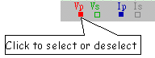
4. Click the switch to open or close it.
5. Change the parameters by dragging the ends of corresponding bars.
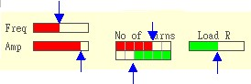
6. Please note that it is pointless to compare the amplitude of a voltage and that of a current when they are dispalyed simultaneously on the screen. They have different units

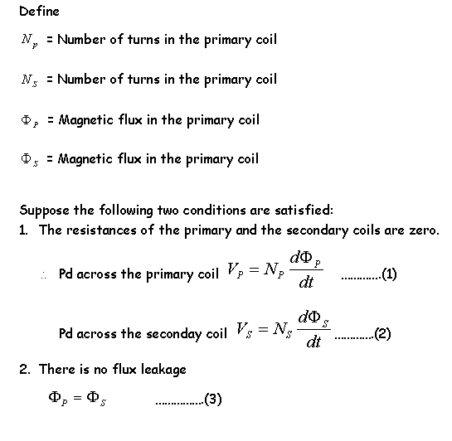
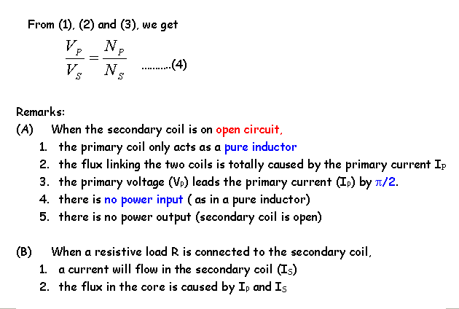
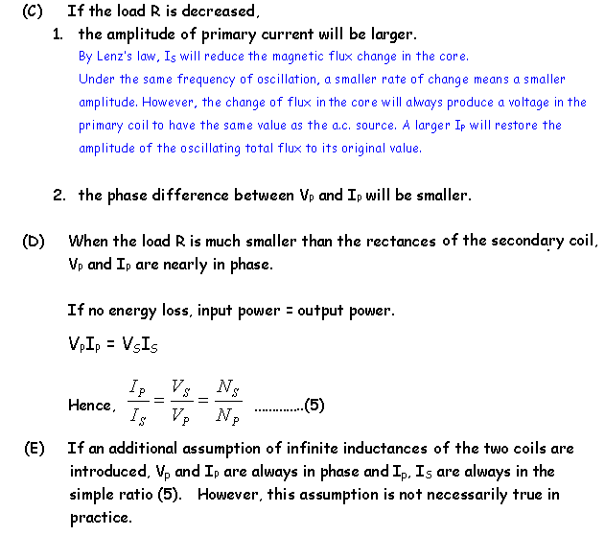
Screenshots of a real transformer
A detailed mathematical analysis of transformer

