1.
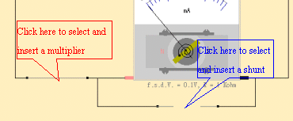 | 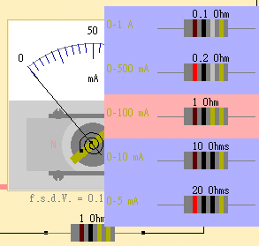
2. Click or drag the part circled in red below will alter the value or the state of the corresponding element.
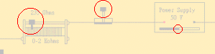
3. "f.s.d.V. " stands for "full-scale-deflection voltage", it is the maximum voltage the meter can measure without the aid of an external resistor. The f.s.d.I. is f.s.d.V./R.
_________________________________________________________________________________________________________________________________
An ammeter can be converted from a galvanometer of small full-scale-deflection current by connecting a small resistor in parallel with it. This small resistor is known as a shunt. A large portion of the current being measured will then flow through the shunt.
A voltmeter can be converted from a galvanometer of small full-scale-deflection voltage by connecting a large resistor in series with it. This large resistor is known as a multiplier. A large portion of the voltage being measured will then drop across the multiplier. _____________________________________________________________________________________________________________________________

