1. Drag and place the B-field directing to the coil, magnetic force(s) will exert on the side(s) which are influenced by the field.
2. The size of the B-field region can be varied by dragging its sides or corners.
3. To avoid electromagnetic induction, the circuit is broken when the B-field or the number of turns is varied.
4. The scale reading is the net vertical force (downward minus upward).
5. 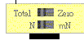
When the switch "Total - Zero" is turned to "Zero", the scale reading will become zero. Any reading shown afterwards is the force added after the switching. "N" and "mN" are units of force; they stand for newton and millinewton respectively.

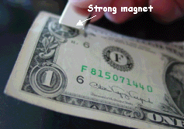
Money is really very attractive!

