* This is a 3D simulation. Drag to change the angle of viewing.
* Sinusoidal voltages are applied to the horizontal and vertical deflection plates, they have the form
V = Asin(2πft + φ), where A is the amplitude, f is the frequency and φ is the phase.
* Deflection plate is red (black) when it is positive (negative).
* The screen is viewed directly from the front when the box "Front" is checked. Click a point on the screen will show the coordinates of that point.
* The Lissajous figures in some books may look different to those generated here. This is most probably in them the cosine function is used instead, i.e. V = Acos(2πft + φ).

Fequencies and phase difference found from the pattern
(I) Same frequency
(a) 0, 90 or 180
 |  | 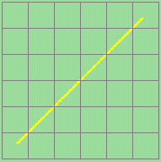 | 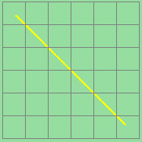
 | phase difference | 0 degree | 180 degree

 |  | 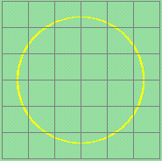 | 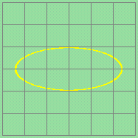 | 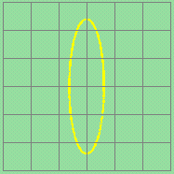
 | phase difference | 90 degree  (amplitude of x = amplitude of y*) | 90 degree  (amplitude of x > amplitude of y*) | 90 degree  (amplitude of x < amplitude of y*)
* Assume same voltage sensitivities
(b) general case
 |  | 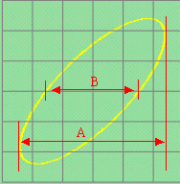 | 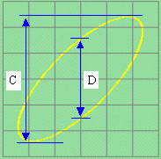
 | phase difference | 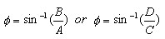

 |  | 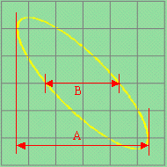 | 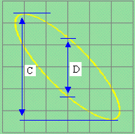
 | phase difference | 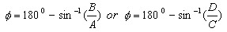
** We do not known x or y is the leader in the phase unless the sense of rotation of the circle or the ellipse is known.
Clockwise rotation: y leads x; antoclockwise rotation: x leads y.

(II) Frequencies are different, but in a simple ratio
The pattern generally depends on their frequencies and initial phases.
The ratio of the frequencies can be found easily by the following method:
 | 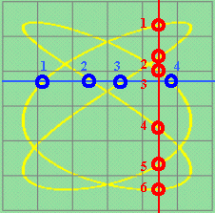 | Draw a vertical and horizontal line to traverse the pattern. The lines should not contain any intersecting point of the curve.  Count the number of the intersection points of the vertical line and the curve. Let this number be m.  As well, count the number of the intersection points of the horizontal line and the curve. Let this number be n.  frequency of x : frequency of y= m : n  In this example, the ratio is 6 : 4 = 3 : 2.
 | 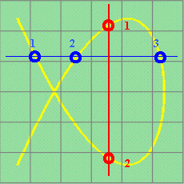 | One more example,  frequency of x : frequency of y = 2 : 3  (The lines should not be drawn to touch the curve as tangents. If so, you may get a wrong ratio in this example.)

